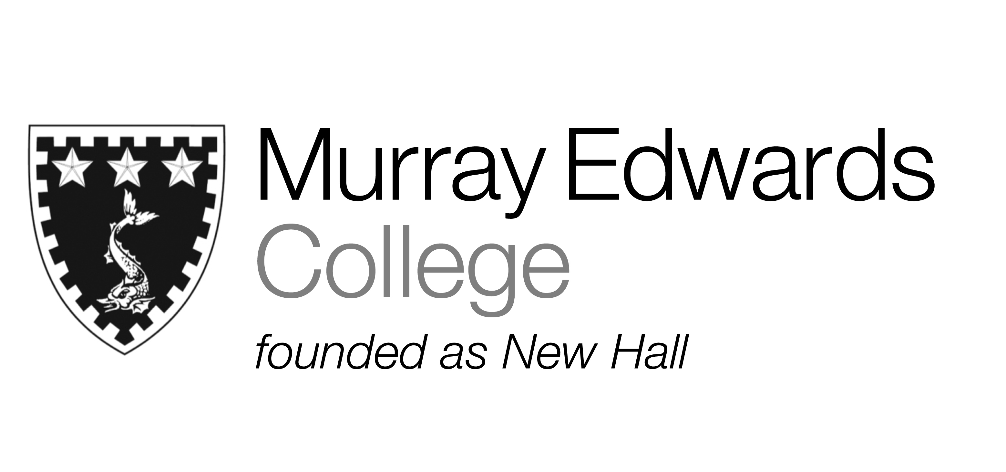

Formal Hall
Tuesday 4th February

Smoked Mackerel Rillettes served with Soda Bread

Slow Cooked Leg of Chicken served with
Moroccan Spiced Lentils

Banana and White Chocolate Bread and Butter Pudding

Please note that meals may contain traces of nut

