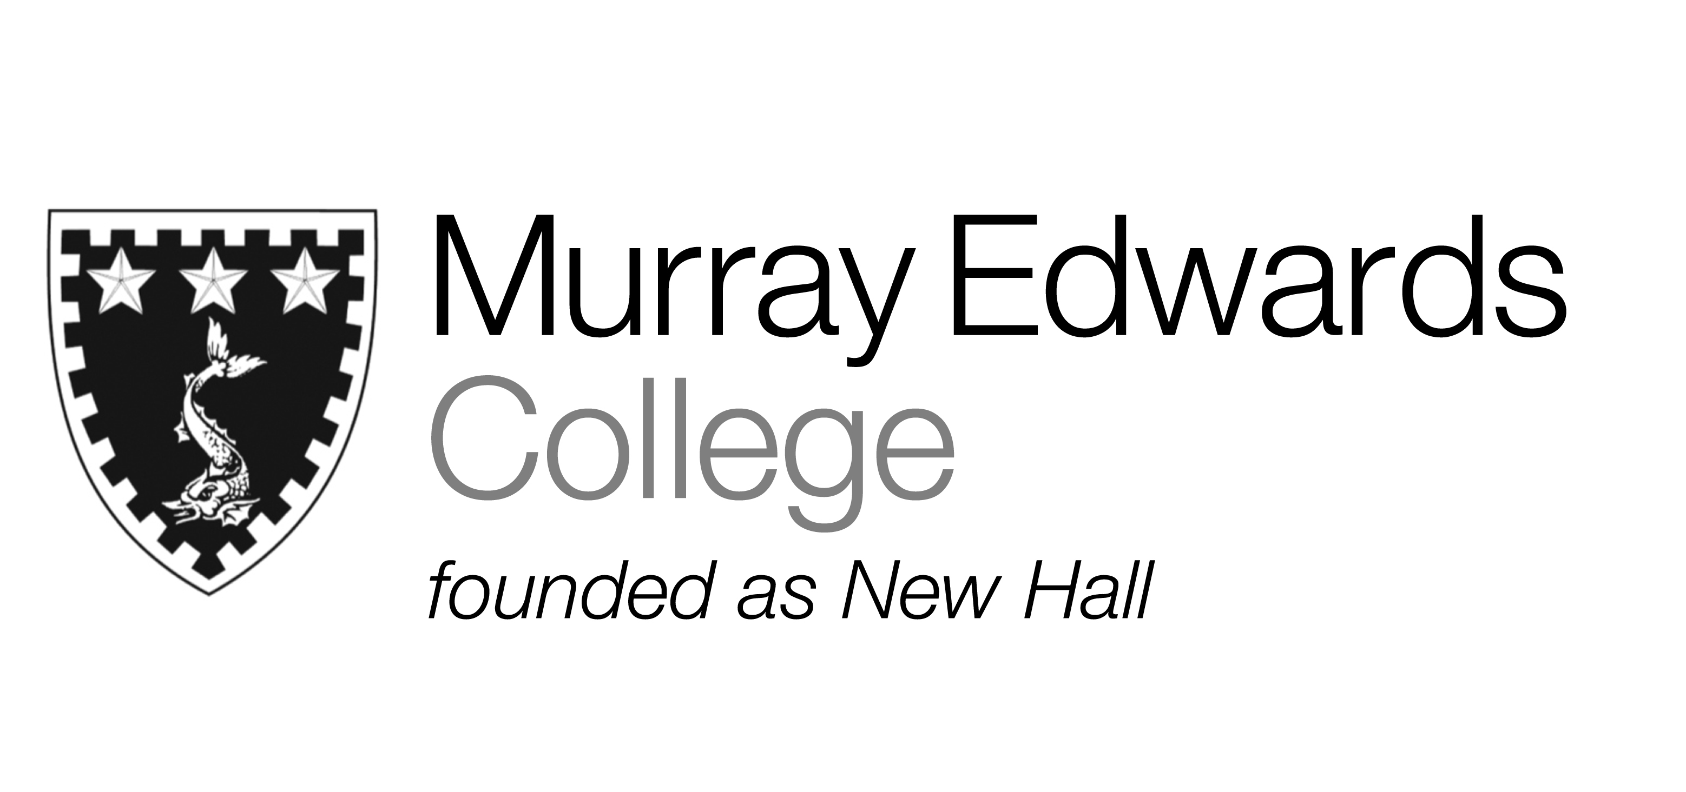

Formal Hall
Tuesday 28th January
Burns night

Whiskey Cured Salmon
served with Oat Cakes and Crème Fraîche

Braised Beef

served with Haggis, Creamed Potato and Roast Neeps

Raspberry Cranachan

Please note that meals may contain traces of nut

