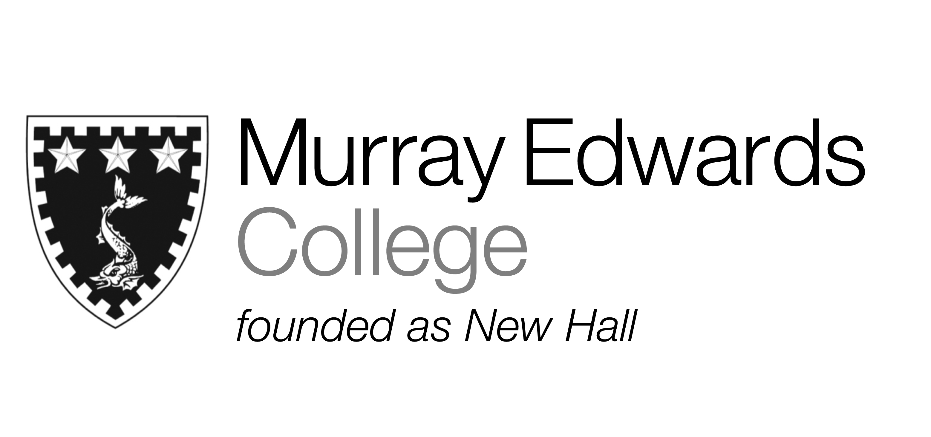

Formal Hall
Tuesday 21st January

Spinach Tortellini with Tomato and Basil Broth

Roast Rump of Lamb with Peas and Broad Bean Fricassee

Banana Cheese Cake served with Toffee Ice Cream

Please note that meals may contain traces of nut

