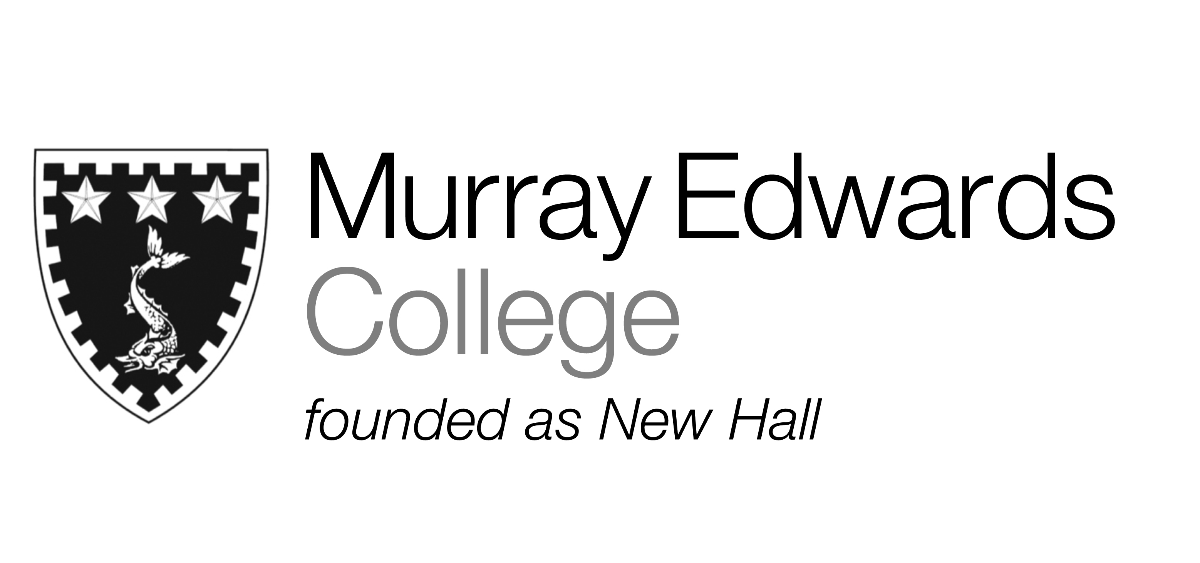

Formal Hall
Friday 7th February

Salad of Parma Ham, Purple Potatoes and Balsamic Onions

Parmesan Crusted Chicken Breast
served with Risotto Milanese

Tiramisu Torte served with Espresso Cream

Please note that meals may contain traces of nut

