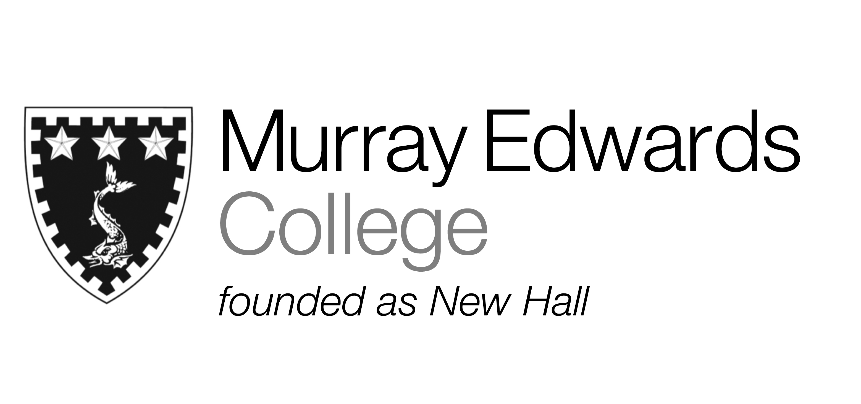

Formal Hall
Tuesday 3rd December
Classic prawn cocktail topped with bloody mary sauce

Roast Norfolk turkey served with sage and onion stuffing,
local sausage wrapped in smoked bacon, cranberry sauce and gravy

Traditional Christmas pudding served with brandy sauce

Please note that meals may contain traces of nut

