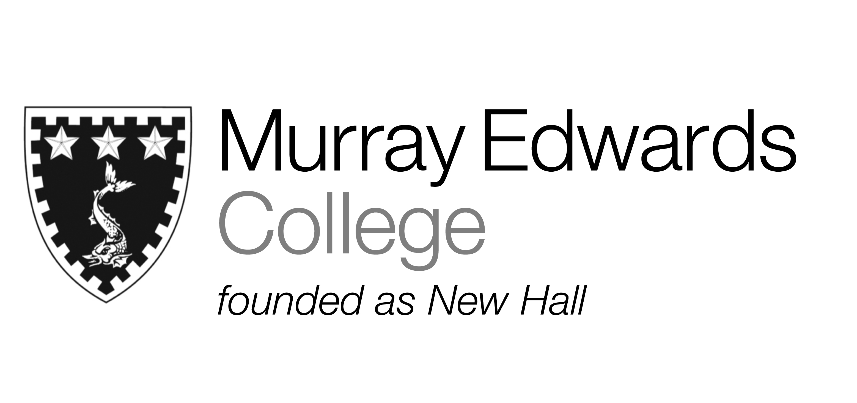

Formal Hall
Tuesday 26th November
(Thanks Giving)
Sweet potato soup with spiced yogurt

Breaded turkey escalope served with tomato fondue and champ potato

Pumpkin pie served with vanilla ice cream

Please note that meals may contain traces of nut

