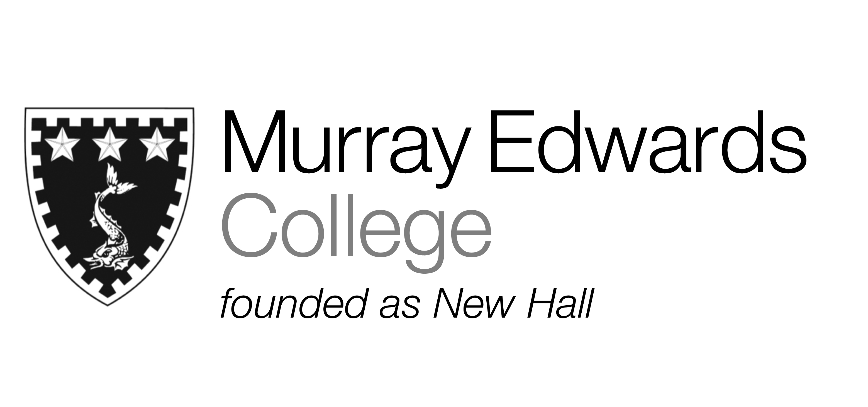

Formal Hall
Friday 18th November
Potted smoked mackerel with crème fraîche and lemon

Slow roast rump of lamb served with dauphinoise potatoes, pea and mint puree

Millionaires tart served with sauce analgise

Please note that meals may contain traces of nut

