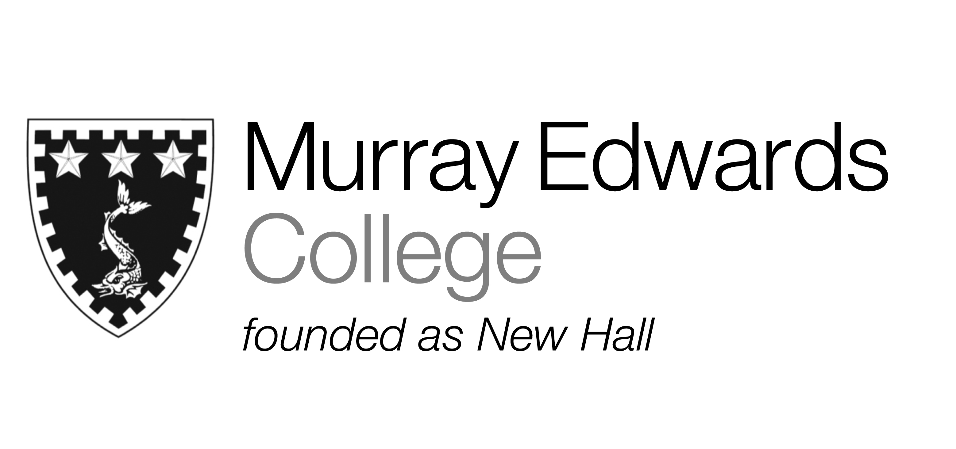

Formal Hall
Tuesday 12th November
Ham hock and parsley terrine with homemade piccalilli

Daube of beef with roast mushrooms and onions
Served with smoked creamed potatoes

Chocolate bread and butter pudding
served with vanilla ice cream

Please note that meals may contain traces of nut

