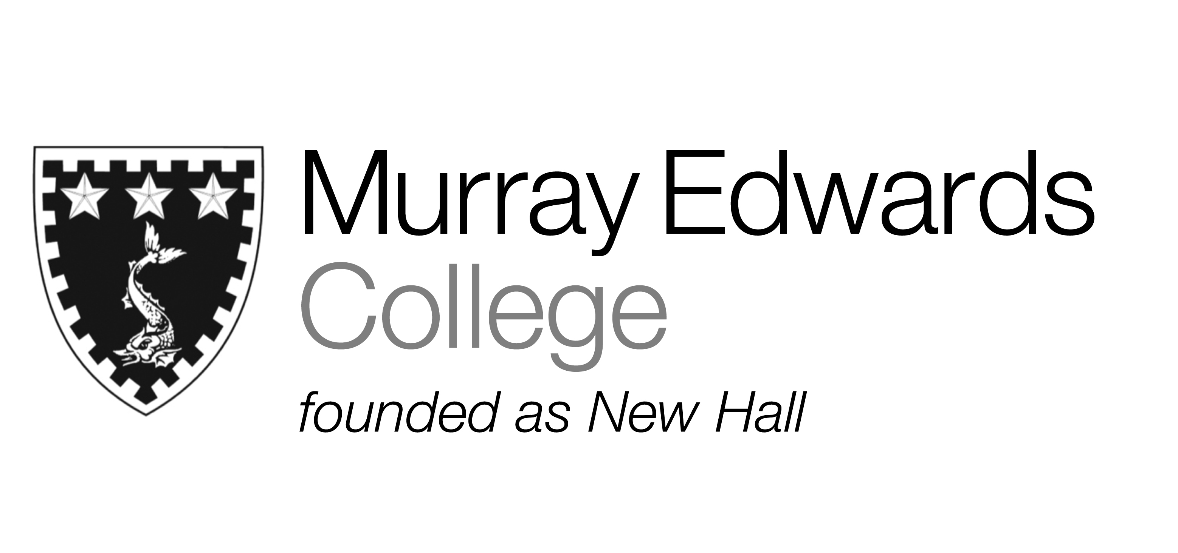

Cafeteria lunch and dinner
Sunday 24th November 2013

Soup

Roast chicken with sage and onion stuffing and gravy

Poached salmon with parsley butter

Quorn sausages and onion gravy

Jacket potatoes with various fillings

Roast potatoes
Mashed sweet potatoes
Cauliflower cheese

Dessert

Please note that meals may contain traces of nuts

