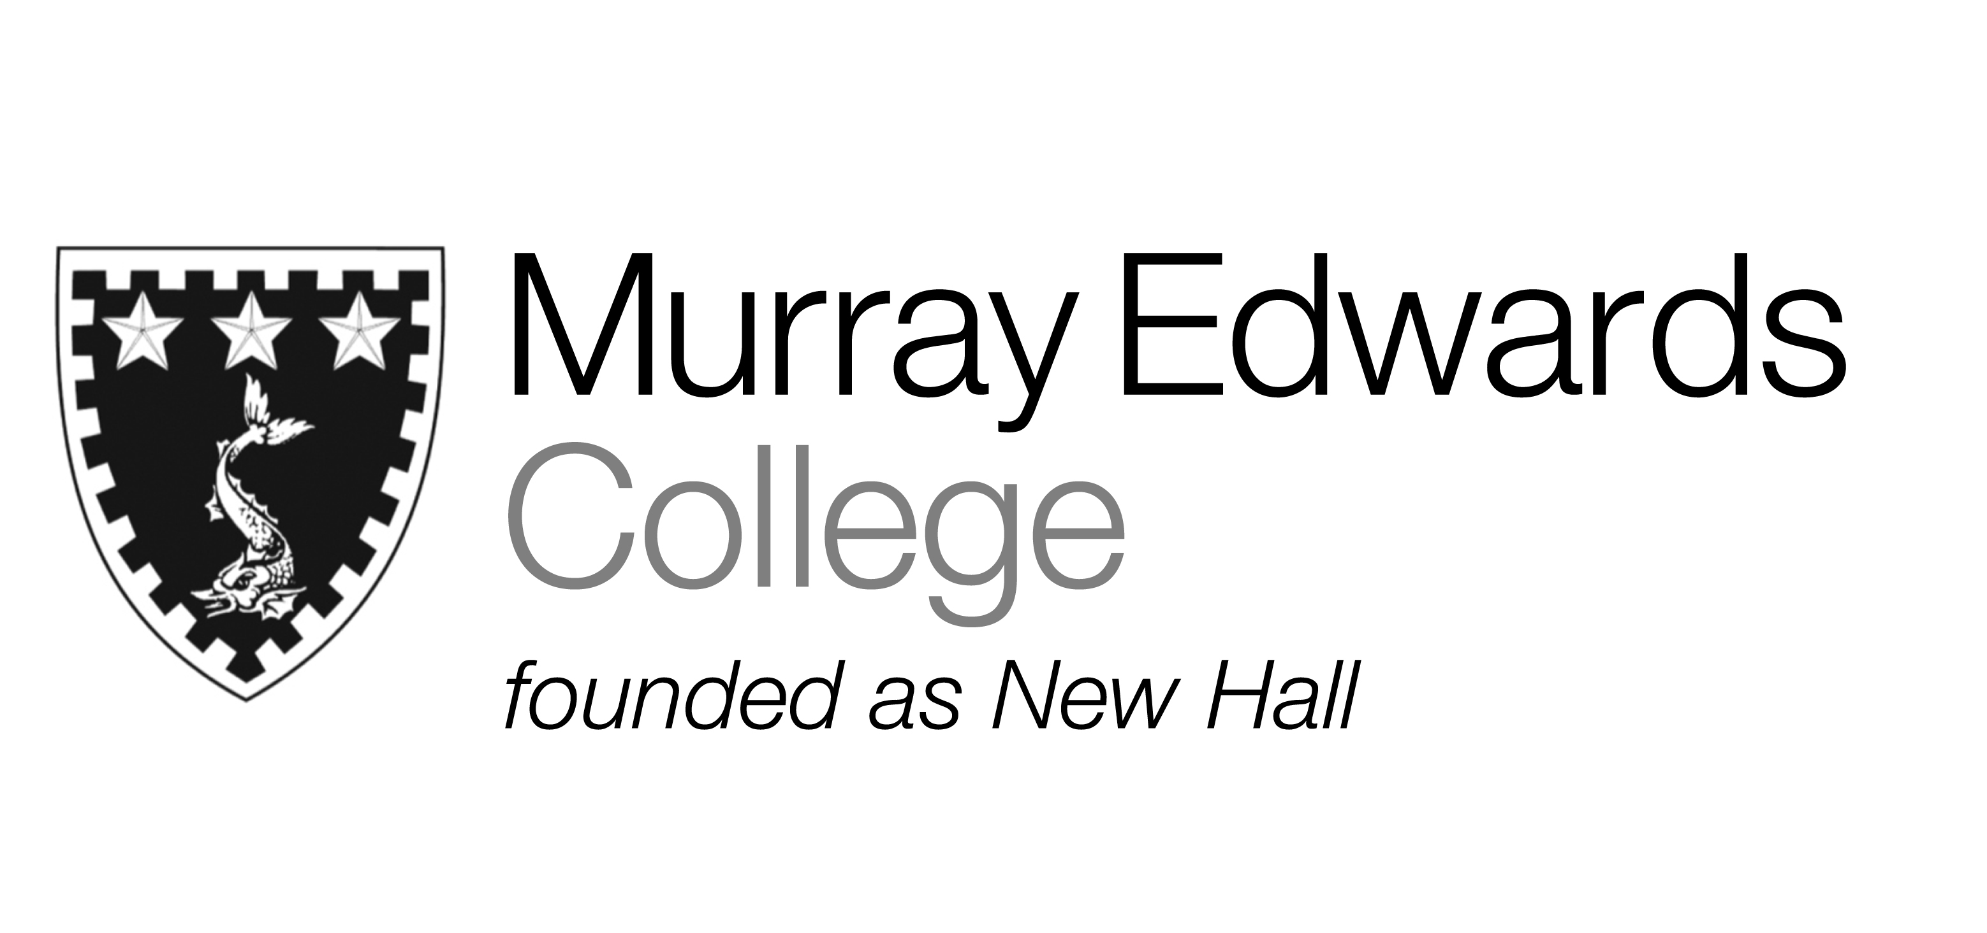

Cafeteria Lunch
Wednesday 20th November 2013

Cream of tomato soup

Garlic and rosemary roasted shoulder of lamb served with gravy

Vegetable and nut roast with vegetarian gravy

Roast market fish with a chive beurre blanc

Jacket potatoes with various fillings

Thyme roast potatoes
Crushed carrot and swede
Fine beans

Dessert
Please note that meals may contain traces of nuts

Cafeteria Dinner
Wednesday 20th November 2013

Soup

Honey and thyme grilled chicken legs

Creamy Vegetable Kiev’s

Salmon fish cakes served with lemon and herb mayonnaise

Jacket potatoes with various fillings

Minted new potatoes
Tossed salad
Steamed Mixed vegetables

Desserts

Please note that meals may contain traces of nuts

