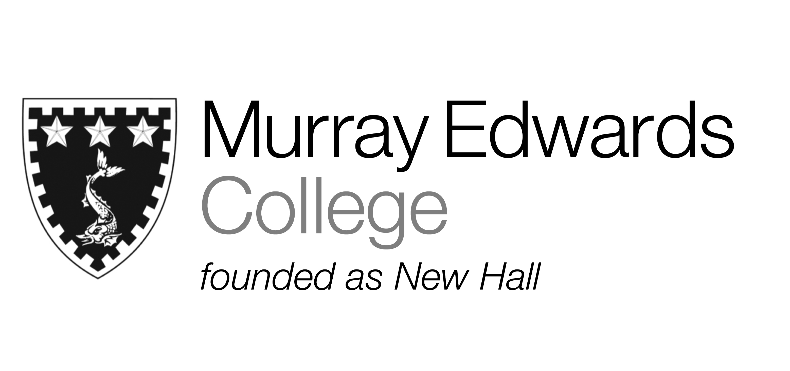

Cafeteria lunch
Monday 18th November 2013

Soup

Baked gammon served with parsley sauce

Poached market fish with a lemon and herb dressing

Olive couscous with marinated vegetables

Jacket potatoes with various fillings

New potatoes
Tossed salad
Peas

Dessert

Please note that meals may contain traces of nuts

Cafeteria Dinner
Monday 18th November 2013

Soup
Marinated chicken burgers
With a selection of toppings

Falafel and pitta bread
With a selection of toppings

Roast market fish served with tomato and mango salsa

Jacket potatoes with various fillings

French Fries
Corn on the cob
Onion rings

Desserts

Please note that meals may contain traces of nuts

