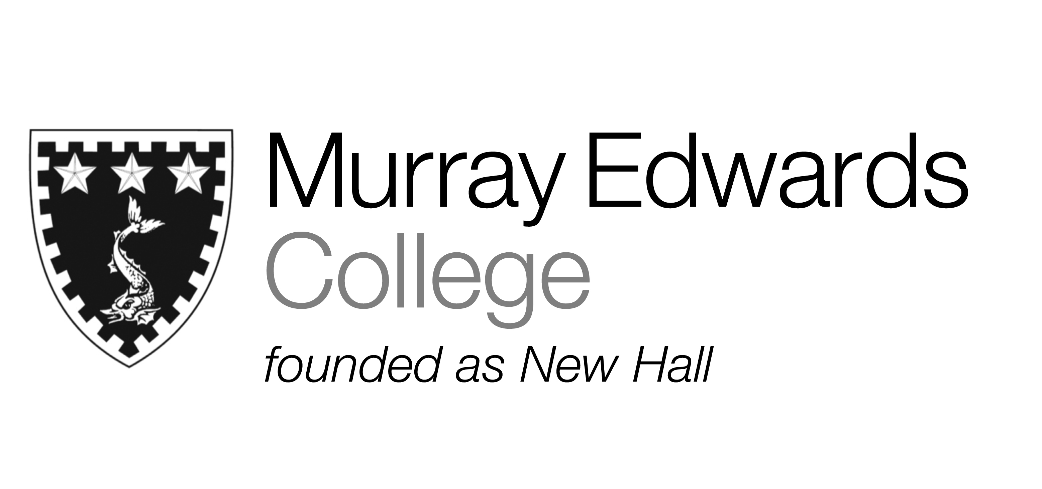

Cafeteria Dinner
Sunday 17th November 2013

Soup

Loin of pork served with apple Sauce and gravy

Poached salmon with pesto alla Genovese

Roast vegetable bake

Jacket potatoes with various fillings

Roast potatoes
Broccoli served with cheese sauce cheese
Carrots

Dessert

Please note that meals may contain traces of nuts

