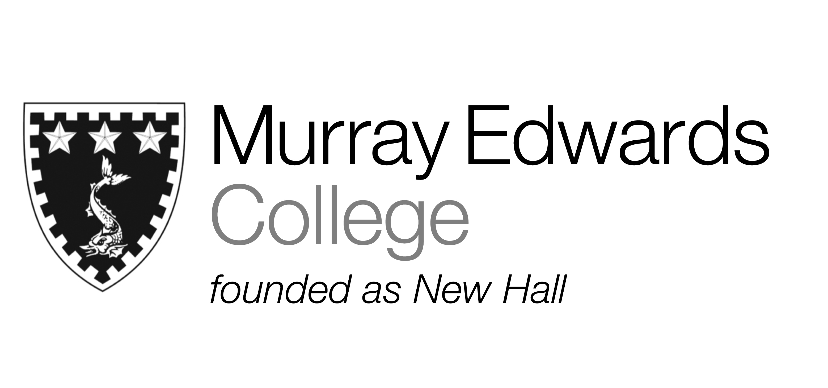

Cafeteria Lunch
Friday 15th November 2013

Soup of the day

Beer battered Cod served with tartar sauce

Spicy chicken legs

Southern fried quorn pieces

Jacket potatoes with various fillings

Fresh Chips
Mushy peas
Corn on the cob

Desserts

Please note that meals may contain traces of nuts

Cafeteria Dinner
Friday 15th November 2013

Soup of the day

Marinated minute steak
Beer battered Cod with tartar sauce and lemon
Courgette fritters served with tomato coulis

Jacket potatoes with various fillings

Fresh chips
Peas
Tossed salad

Dessert

Please note that meals may contain traces of nuts

