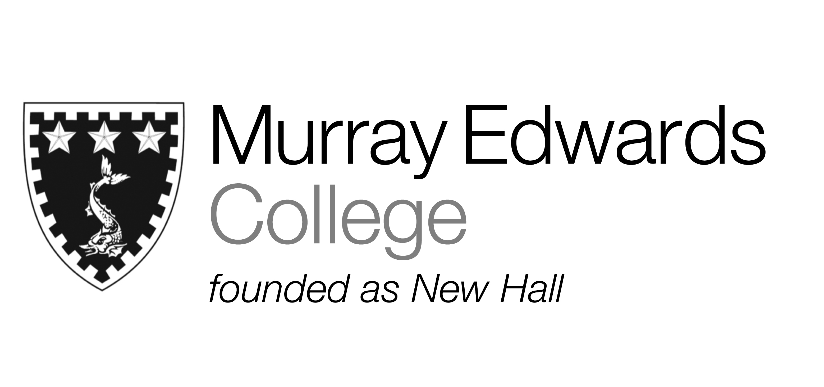

Cafeteria Lunch
Thursday 14th November 2013
Soup of the day

Chicken Jalfrezi served with a
Selection of chutneys pickles and poppadum’s

Roast Cod spiced potatoes and spinach

Cauliflower and chick pea curry with a
Selection of chutneys pickles and poppadum’s

Jacket potatoes with various fillings

Rice
Peas

Desserts

Please note that meals may contain traces of nuts

Cafeteria Dinner
Thursday 14th November 2013

Soup of the day

Beef madras

Mixed vegetable curry

Tai spiced market fish

Jacket potatoes with various fillings

Rice
Vegetable samosas
Tossed salad

Desserts

Please note that meals may contain traces of nuts

