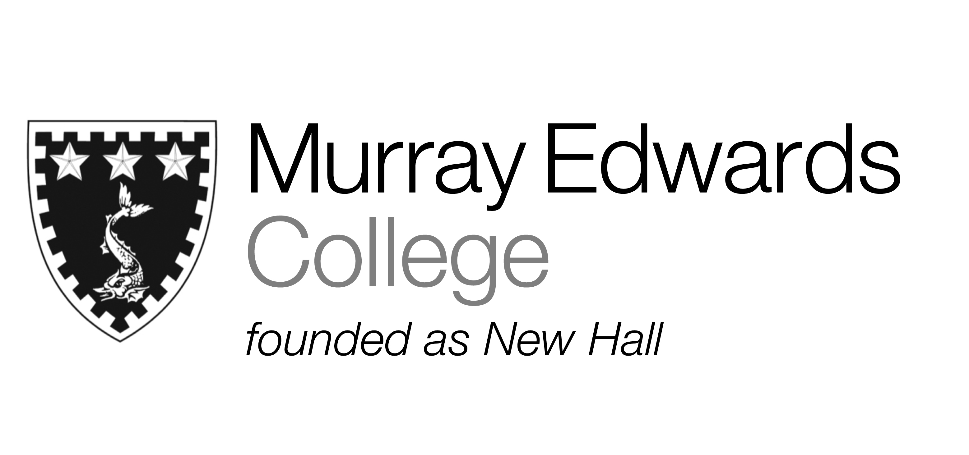

Cafeteria Lunch
Wednesday 13th November 2013

Soup of the day

Roast chicken served with Yorkshire pudding and gravy

Fish pie with an herb creamed potato topping

Vegetarian sausage served with sautéed peppers and onions

Jacket potatoes with various fillings

Roast potatoes
Leeks baked in cheese sauce
Honey glazed Carrots

Dessert

Please note that meals may contain traces of nuts

Cafeteria Dinner
Wednesday 13th November 2013

Soup of the day

Chicken a la king

Poached haddock, chive beurre blanc

Mushroom stroganoff

Jacket potatoes with various fillings

Buttered new potatoes
Steamed rice
Mixed vegetables

Desserts

Please note that meals may contain traces of nuts

